Regression and Optimization (Multi Linear and Polynomial regression)

SCENARIO 1 – MULTILINEAR REGRESSION

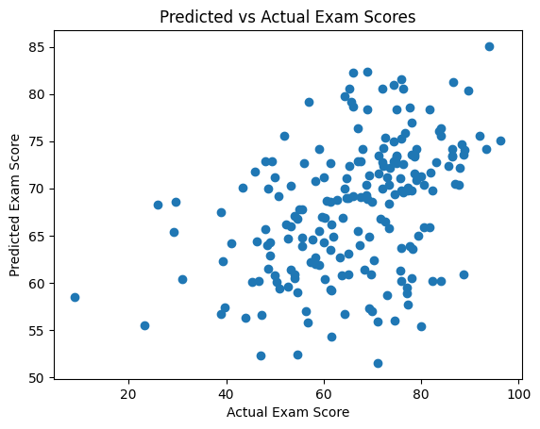
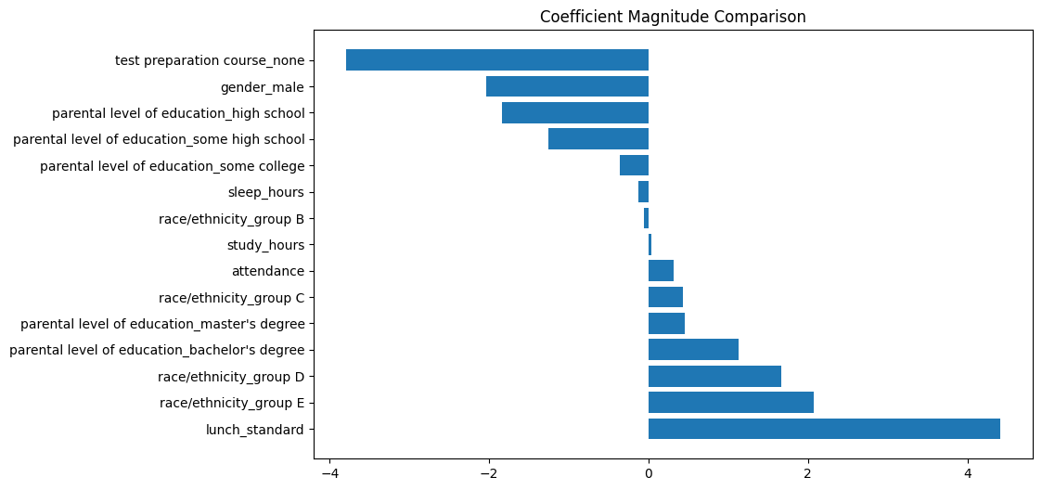

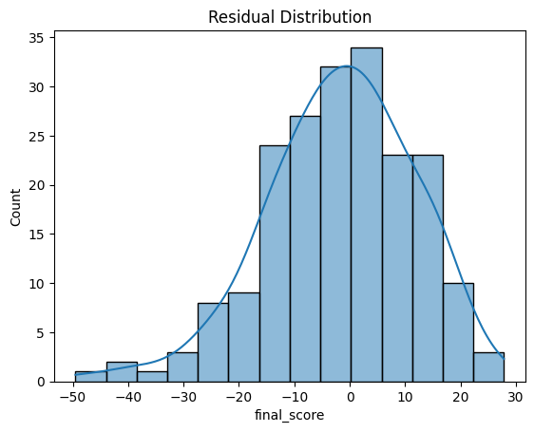

SCENARIO 2 – POLYNOMIAL REGRESSION

